
INDIAN SCHOOL AL WADI AL KABIR
MID TERM EXAMINATION 2025-26

ARTIFICIAL INTELLIGENCE (417)

Class: X Max Marks: 50
Date: 25-09-2025 Time: 2 Hour

General Instructions:
- Please read the instructions carefully.
- This Question Paper consists of 20 questions in two sections: Section A & Section B.
- Section A has Objective type questions whereas Section B contains Subjective type questions.
All questions of a particular section must be attempted in the correct order.

SECTION A - OBJECTIVE TYPE QUESTIONS (24 MARKS):
  - This section has 5 questions with internal choices.
  - Marks allotted are mentioned against each question/part.
  - There is no negative marking.
  - Do as per the instructions given.

SECTION B – SUBJECTIVE TYPE QUESTIONS (26 MARKS):
  - This section has 15 questions.
  - A candidate has to do 10 questions.
  - Do as per the instructions given.
  - Marks allotted are mentioned against each question/part.

SECTION A: OBJECTIVE TYPE QUESTIONS

1 | Answer any 4 out of 5 questions from Employability skills
i | Which of the following is NOT an element of communication within the communication process cycle?  (a) Channel  (b) Receiver  (c) Sender  (d) Time | 1
ii | Which of the following is an example of oral communication?  (a) Newspapers  (b) Letters  (c) Phone call  (d) e-mail | 1
iii | Which of these are examples of positive feedback?  (a) Excellent, your work has improved.  (b) I did not notice your dedication towards the project.  (c) You are always doing it the wrong way.  (d) All of the above | 1
iv | Ravi works hard to get the best student award at the end of year. What type of motivation is this?  (a) Internal  (b) External  (c) Both internal and external  (d) Not any specific type of motivation | 1
v | Which of these sentences is in active voice?  (a) A movie is being watched by them.  (b) The car was repaired by Raju.  (c) He is reading a book.  (d) The thief was being chased by a policeman. | 1
2 | Answer any 5 out of 6 questions from subject specific skills
i | Read the examples given below-  - Using Chat GPT to write an email  - Face unlock technology of mobile phones using camera  - Turning off lights with IoT device  - Hand sanitizer dispenser having sensor  Choose the options that are not AI  (a) i and ii  (b) iii and i  (c) iii and iv  (d) i, iii and iv | 1
ii | What is the main goal of Computer Vision projects?  - Translating audio data into visual descriptions  - Converting digital data into analogue signals  - Teaching machines to understand textual information  - Converting digital visual data into computer-readable language | 1
iii | The Indian Government banned a few apps stating – “servers in the hostile nation are receiving and using the acquired data improperly”. Which terminology suits best for this action?  (a) AI Ethics  (b) Data Privacy  (c) AI Bias  (d) AI Access | 1
iv | Assertion: Ethics provide guidance in distinguishing right from wrong.  Reasoning: Ethics consist of a set of values and morals that aid individuals in making moral judgments and decisions.  - Both Assertion and Reasoning are true, and Reasoning is the correct explanation of the Assertion.  - Assertion is true, but Reasoning is false.  - Both Assertion and Reasoning are true, but Reasoning is not the correct explanation of the Assertion.  - Assertion is false, but Reasoning is true. | 1
v | Statment1: The output given by the AI model is known as reality.  Statement2: The real scenario is known as Prediction.  (a) Both Statement1 and Statement2 are correct  (b) Both Statement1 and Statement2 are incorrect  (c) Statement1 is correct but Statement2 is incorrect  (d) Statement2 is correct but Statement1 is incorrect | 1
vi | F1 Score is the measure of the balance between  (a) Accuracy and Precision  (b) Precision and Recall  (c) Recall and Accuracy  (d) Recall and Reality | 1
3 | Answer any 5 out of 6 questions from subject specific skills
i | What is the primary domain of application for Bioethics?  - Agriculture  - Healthcare and life sciences  - Information technology  - Environmental conservation | 1
ii | What is the purpose of defining the problem statement during the Problem Scoping stage in an AI project cycle?  - To collect data  - To understand the aim and objective of the project  - To train the model  - To process data | 1
iii | Which learning approach uses labelled data for training?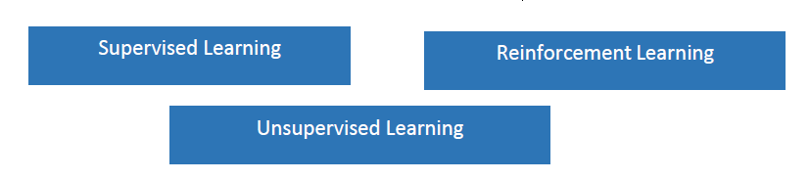  c.  b.  a. | 1
iv | Assertion: Unsupervised Learning is a type of learning without any guidance.  Reasoning: Unsupervised learning models work on unlabelled datasets, where the data fed into the machine is random and the person training the model may not have any prior information about it.  - Both A and R are true and R is the correct explanation for A  - Both A and R are true and R is not the correct explanation for A  - A is True but R is False  - A is false but R is True | 1
v | In a medical test for a rare disease, out of 1000 people tested, 50 actually have the disease while 950 do not. The test correctly identifies 40 out of the 50 people with the disease as positive, but it also wrongly identifies 30 of the healthy individuals as positive. What is the accuracy of the test?  - 97%  - 90%  - 85%  - 70% | 1
vi | Identify the model: Predicting whether a customer is eligible for a bank loan or not?  a) Classification  b) Regression  c) Both a. and b.  d) None of the above | 1
4 | Answer any 5 out of 6 questions from subject specific skills
i | Which of these is an example of AI in e-commerce applications?  a) Login  b) checkout  c) Recommendations  d) Logout | 1
ii | Aditi, a student of class XII developed a chatbot that clarifies the doubts of Economics students. She trained the software with lots of data sets catering to all difficulty levels. If any student would type or ask questions related to Economics, the software would give an instant reply. Identify the domain of AI in the given scenario.  a) Computer Vision  b) Data Science  c) Natural Language Processing  d) None of these | 1
iii | Statement1: There are four layers in a neural network.  Statement2: The first layer of the neural network is known as the output layer.  a) Both Statement1 and Statement2 are correct  b) Both Statement1 and Statement2 are incorrect  c) Statement1 is correct but Statement2 is incorrect  d) Statement2 is correct but Statement1 is incorrect | 1
iv | _________ ___________is defined as the percentage of correct predictions out of all the observations.  a) Overfitting  b) Accuracy  c) Confusion Matrix  d) Data acquisition | 1
v | How are Ethical Frameworks for AI categorized?  a) Into legal and illegal frameworks  b) Into sector-based and value-based frameworks  c) Into historical and contemporary frameworks  d) Into theoretical and practical frameworks | 1
vi | __________________________ refer to the type of data you want to collect.  a) Data features  b) Exploring Data  c) Data Acquisition  d) All of the above | 1
5 | Answer any 5 out of 6 questions from subject specific skills
i | Clustering is learning and its goal is to?  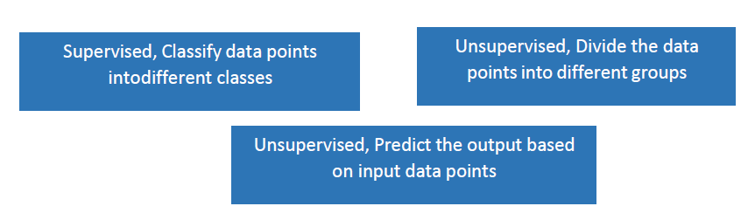  c.  b.  a. | 1
ii | Assertion (A): Neural networks are the backbone of deep learning algorithms  Reasoning (R): Neural networks use vast amounts of data  a) Both A and R are correct and R is the correct explanation of A  b) Both A and R are correct but R is NOT the correct explanation of A  c) A is correct but R is not correct  d) A is not correct but R is correct. | 1
iii | ___________ is the process of understanding the reliability of any AI model, based on outputs by feeding test dataset into the model and comparing with actual answers.  a) Evaluation  b) Problem Scoping  c) Data acquisition  d) Data Exploration | 1
iv | The result of comparison between the prediction and reality can be recorded in what we call the __________.  a) Overfitting  b) Problem Scoping  c) Confusion Matrix  d) Data acquisition | 1
v | The _______________ is the fifth stage of the AI project cycle.  a) Problem Scoping  b) Data Evaluation  c) Data Exploration  d) Data Modelling | 1
vi | Whenever we want an AI project to be able to predict an output, we need to _______________ it first using data.  a) Analyze  b) Train  c) Explore  d) All of the above | 1
SECTION B: SUBJECTIVE TYPE QUESTIONS

Answer any 3 out of the given 5 questions on employability skills in 20 – 30 words. (2 x 3 = 6 marks)
Q. 6 | Explain any 2 different types of verbal communication. | 2
Q. 7 | Describe stress and stress management | 2
Q. 8 | What do you mean by feedback? | 2
Q. 9 | What is Goal Setting? | 2
Q. 10 | Write down the common communication barriers you may come across when you move to a new city or country. | 2

Answer any 4 out of the given 6 questions in 20 – 30 words. (2 x 4 = 8 marks)
Q. 11 | Explain Artificial Neural Networks with diagram. | 2
Q. 12 | Define F1 score with the formula. | 2
Q. 13 | Explain train-test procedure in evaluation. | 2
Q. 14 | Explain the terms in confusion matrix:  - True Positive  - True Negative  - False Positive  - False Negative. | 2
Q. 15 | List the ethical concerns around model evaluation | 2
Q. 16 | What do you mean by Unsupervised Learning Model and name the Sub-categories of Unsupervised Learning Model. | 2

Answer any 3 out of the given 4 questions in 50– 80 words each (3x 4 = 12 marks)
Q. 17 | Explain Machine Learning with 2 real time examples. | 4
Q. 18 | Identify TP, TN, FP, FN and calculate Accuracy, Precision, Recall and F1 score for the below confusion matrix:  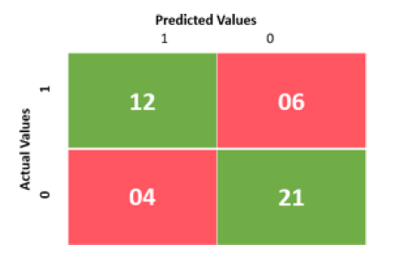 | 4
Q. 19 | Explain AI Domains with a real time example. | 4
Q. 20 | Identify and explain the learning models shown in the picture  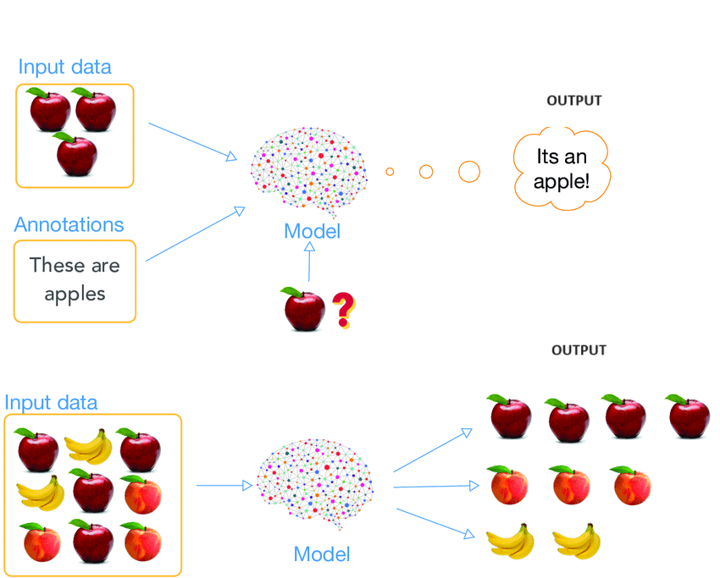 | 4

